# Scheduled Publishing

## Overview

The purpose of Scheduled Publishing is to give the content editor the option to delay the publishing of an item for a future point in time. Thus, a page or a feature that should go live at a specific time can be created and populated in Sitecore and previewed long before it goes live without the risk of an accidental publish before the specific time. Moreover, there is no need for a content-editor to go to Sitecore and manually publish something at an inconvenient hour, e.g. New Year’s announcement.

## Features

* Schedule Publishing
* Schedule Unpublishing
* Edit publishing schedule
* Date and time can be customized
* Warning if the content-editor selects a date that has already passed
* Check if the item is in a valid publishing state
* Check if the item’s publishing restrictions allow publishing according to the desired schedule
* Target database to which to publish
* Frequency of checks whether there are items queued for publishing
* Simple interface
* Email notification when an item gets published

## Guide

This is how the Publish Ribbon looks now:

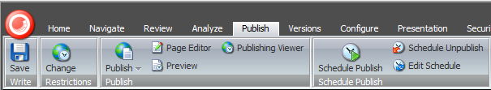

Please notice the rightmost strip called Schedule Publish. You can still use the well-known Publish button for immediate publishing. The Schedule Publish button is what is used only for scheduling a future publish.

The Schedule Publish strip consists of three buttons:

* Schedule Publish button for scheduling a future publishing of the current item
* Schedule Unpublish button for scheduling a future unpublishing of the current item
* Edit Schedule button where the content editor can review, edit and delete any of the existing schedules for any items.

## Schedule Publish

This is how the Schedule Publish dialog looks like:

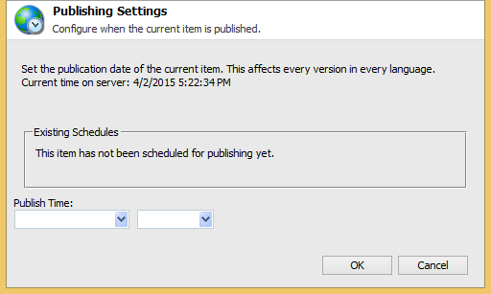

Please note that the current server time will be used when scheduling and it is indicated in the text above.

Any existing schedules for the selected item will display in order in the Existing Schedules block. If there are none, this will be indicated.

As you see the input is fairly simple - two dropdown menus.

From the first drop down you choose a date when to publish. If you choose a date that has passed, you will receive a warning and be returned to the dialog again until you choose a valid date:

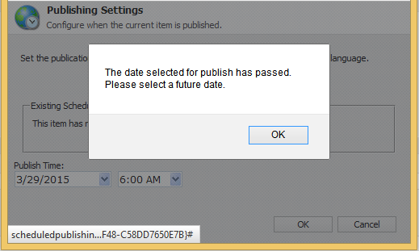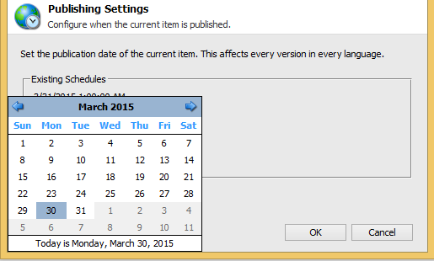

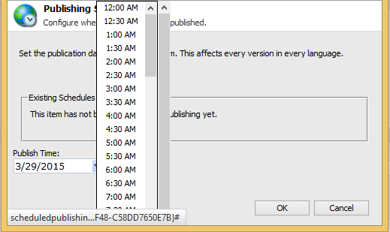From the second dropdown, you should choose an approximate time for publishing. I am saying approximate, since the actual time of publshing will be the time you set +/- the frequency of the check for items for publishing queued:

Sitecore displays only hours and halves, but you can manually edit the selected value afterwards, as long as you keep the time format. However, since the check will most often run hourly, if you edit the time to 3:47 AM for example, it will not have effect on the real publishing time.

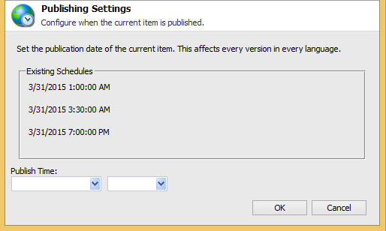If there are already scheduled publishes for the particular item, a list of these will appear above. The list will show all dates and corresponding hours for publishing for the item in order.

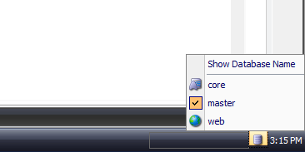After you click OK, the item has been scheduled for publishing. You can test that by creating a new item in the Master database and only scheduling publishing for it, without publishing it the well-known way beforehand. Or, you can switch to the Web database in the bottom right corner and delete a page from there. Then go back to the Master database and schedule publishing for that item.

## Schedule Unpublish

The Schedule Unpublish dialog is identical to the Schedule Publish one, only it will remove an item from the website at the selected time.

## Edit Schedule

The Edit Schedule button will pop the Edit Scheduled Publishing dialog. This dialog does not concern with the item you are currently on. It will list all scheduled publishings for all items in order.

The first column – Item - shows the name of the item and its path, since there may be items with the same name in different locations, especially in a multi-site environment.

The second column – Unpublish – notifies whether the item is scheduled for Unpublishing or, if the value is “No”, it is scheduled for Publishing.

The third column – Date – first shows the current date and time of the schedule, and then two drop down menus for date and time respectively. The first line will not change when you select a different value below – it is just for reference. If you save the new value for any item, the first line will display this new value on reopening the Edit Scheduled Publishing dialog.

The fourth column – Delete – consists of a checkbox. Checking that checkbox will delete the selected schedule.

